**Amsterdam Paralympics**

**Group 14: Fatima Zohra Rouidi, Pelle Topper, Nina Lobo**

**Assignment 1: Canals**

The goal of this assignment was to plan a safe, minimally disruptive route for a 5-kilometer Paralympic swim event in Amsterdam next May. We took various factors into account and initially selected a route by hand (Figure 3).

The majority of our data comes from maps of water quality indicators, charts of canal use data, and research papers or reports from the Municipality of Amsterdam and regulations for open water swimming events. We did not find any relevant .csv files. One of these resources was temporal—Figure 2, the chart of canal activity on an hourly basis—and a few maps were geospatial, but they did not require analysis in Python. Critical sources are listed at the end of Assignment 1.

We have incorporated all of these factors into the map below and ultimately assessed which routes do not impact commercial water transport, have minimal impact on canal boat activity, and provide good water and air quality for swimmers. Below that, we provide an overview of the factors evaluated.

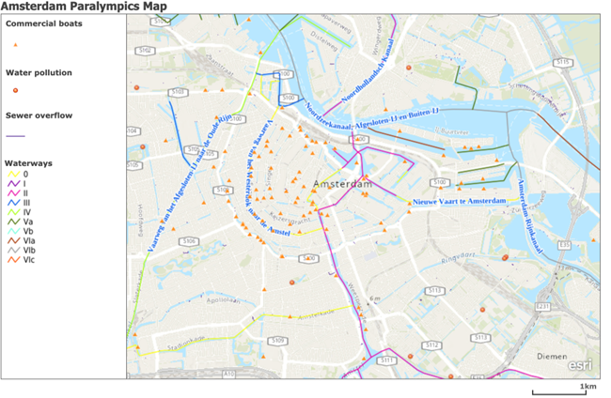

***Figure 1. Amsterdam Paralympics Map***

***Waterways***

*Canal Activity*

To start, we examined the waterways in the Amsterdam canals. Figure 1 illustrates which water routes are utilized in Amsterdam and their levels of activity. In Figure 2 (Figuur 2), a more detailed chart shows most active waterways and intersections across Amsterdam’s canal network in hourly intervals. In short, we evaluated:

* Time and usage data for the canals
* Times and locations for touristic boat platforms along the canals

Our assumption was that *canal boats* refers to all boats primarily used for tourism. Based on this assumption, we excluded recreational boats. Using Map X, we pinpointed the locations of these commercial canal boats. From there, we used Figure 2 to determine which canals would be the least obstructed by a weekend event.

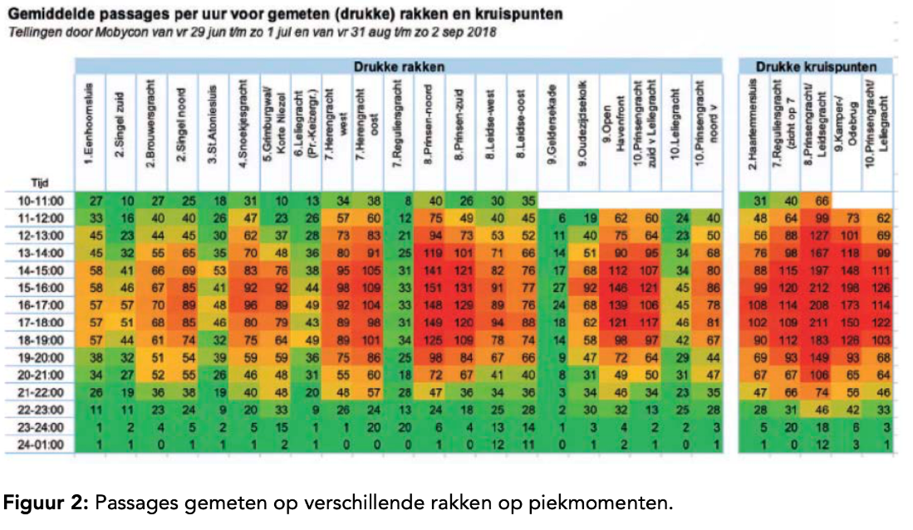

*Figure 2 is found in the* [*Analyserapport Transport over Water (direct download link).*](https://www.bing.com/ck/a?!&&p=1110622a7bdde580JmltdHM9MTY5NTA4MTYwMCZpZ3VpZD0zMWI4ZTBkOS1lNWE2LTZjMWMtMjcxZC1mMzU2ZTRlNTZkNGImaW5zaWQ9NTE5MQ&ptn=3&hsh=3&fclid=31b8e0d9-e5a6-6c1c-271d-f356e4e56d4b&psq=analyse+rapport+transport+over+water&u=a1aHR0cHM6Ly9hc3NldHMuYW1zdGVyZGFtLm5sL3B1Ymxpc2gvcGFnZXMvODYyOTE0L2FuYWx5c2VyYXBwb3J0X3RyYW5zcG9ydF9vdmVyX3dhdGVyLnBkZg&ntb=1)

*Pollution*

To ensure a healthy environment for the swimmers, we evaluated several water quality indicators. Our team prioritized the following from a wide list of factors ([Water in kaart | Waterschap AGV):](https://www.agv.nl/onze-taken/schoon-water/waterkwaliteit/)

* **Turbidity:** Lower turbidity translates to clearer water, ideally less polluted.
* **Oxygen content:** higher oxygen content is indicative of healthy water flow and aeration, which implies less water stagnancy and minimal pollution along the route. ([Source](https://unievanwaterschappen.nl/waterkwaliteit-verslechtert-door-hitte-en-droogte/))
* **Effluent points for treated sewage water**: To eliminate any possibility of exposure to concentrated pollutants from water treatment plants, it is preferable to avoid effluent points.

***Findings***

Taking all of this into consideration, we concluded that the major activity on the waterways begins around 11 o'clock. Therefore, it would be advisable to begin our swimming tour early and conclude it before this surge in traffic begins.

Assuming an average person takes 2.5 hours to swim 5 kilometers, we have decided to operate the swimming tour from 7 o'clock to 11 o’clock, allowing swimmers a four-hour window to account for late starts, emergencies, and avoiding boat activity. The selected route is below (Figure 3).

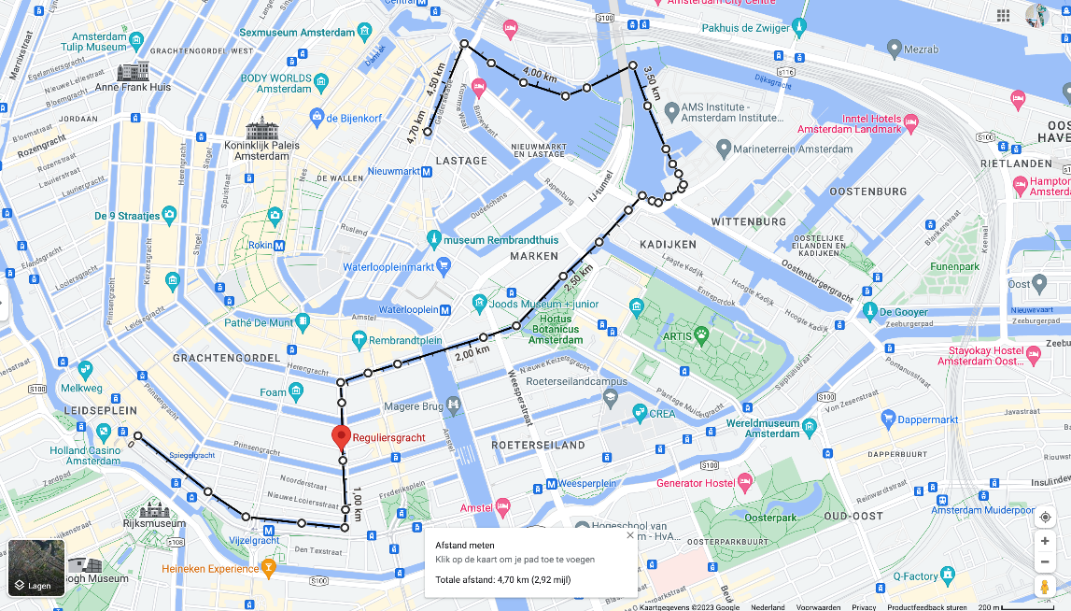

***Figure 3. Recommended Route for the Amsterdam Paralympic 5K Swim in May 2024.***

Key Sources for the Municipality of Amsterdam:

|  |  |  |  |  |  |
| --- | --- | --- | --- | --- | --- |
| Description | Source | Data format | Numerical? | Python libraries | How geometrically  represented |
| Water quality in Amsterdam | [Dataset: Water in Amsterdam | Website Onderzoek en Statistiek](https://onderzoek.amsterdam.nl/dataset/water-in-amsterdam) | Excel file (.csv) | Yes | openpyxl |  |
| Map with turbidity, salt, and oxygen | [Water in kaart | Waterschap AGV](https://www.agv.nl/onze-taken/schoon-water/waterkwaliteit/) | Map | Yes, there are numbers displayed on the map |  | Points |
| Map Amsterdam sewer system | [Amsterdecks | Brengt water dichtbij met een slim zwemvlonder dat de waterkwaliteit direct zichtbaar maakt.](https://amsterdecks.com/over-waterkwaliteit/riolering/) | Map | No |  | Lines and points |
| Sewer system, commercial boat, | [Data en informatie (amsterdam.nl)](https://data.amsterdam.nl/data/geozoek/?center=52.3693048%2C4.885651&lagen=ondrgd-waternrlg%7Condrgd-waternrlhws%7Condrgd-waternrlprs%7Condrgd-waternrlvgm%7Condrgd-waternrlvgs%7Condrgd-waternrlvws&legenda=true) | Map |  |  |  |

**Assignment 2: Tour Boats**

This assignment seeks to reduce air pollution from canal boats and support boats. As a result, the health and safety of event participants should be prioritized.

**1. How many of the canal boats currently in use are diesel/fossil fuel-driven and how**  
**many boats are electric?**

In 2024: Based on a canal fleet of 310 canal boats, at least 90% of canal boats will be electric (around 280 boats), and 10% will still be diesel-driven (around 30 boats).

The Amsterdam canal cruise fleet contained 310 boats in 2016. While this number is highly likely to have changed in seven years, we use it for the purpose of the calculations. In 2020, 75% of the registered commercial vessels in Amsterdam were already electric ([Reuters](https://www.reuters.com/article/us-climate-change-netherlands-idUSKBN20Q1W7)), which includes canal boats.

The city is aiming for all commercial and residential boats to be emissions-free by 2025 ([Elektrisch varen - Gemeente Amsterdam](https://www.amsterdam.nl/verkeer-vervoer/varen-amsterdam/elektrisch-varen/)). Because the swim takes place in 2024, additional boats must be electrified to reach the 2025 goal. By linear regression, we assume that at least 90% of the Amsterdam canal cruise fleet will be electric by mid-2024.

**2. Are there peak times for the canal boats?**

The canals have variable traffic times, which are represented in Figure 2 in Assignment 1. For our hand-selected route and event timing, we selected canals with minimal traffic and optimized for the early morning to avoid commercial boats.

**3. Do canal boats use more or less energy in relation to their carbon footprint compared to other activities in the city?**

To power a cruise fleet of 310 boats, the amount of energy needed per year is 9000 MWh. This is equivalent to 2.3 million liters of diesel ([TNO 2016 Elektrische Rondvaart in Amsterdam](https://www.bing.com/ck/a?!&&p=80bfd0a033940f53JmltdHM9MTY5NzY3MzYwMCZpZ3VpZD0zMWI4ZTBkOS1lNWE2LTZjMWMtMjcxZC1mMzU2ZTRlNTZkNGImaW5zaWQ9NTE5MA&ptn=3&hsh=3&fclid=31b8e0d9-e5a6-6c1c-271d-f356e4e56d4b&psq=TNO+2016+R10481+Elektrische+rondvaart+in+Amsterdam&u=a1aHR0cHM6Ly9wdWJsaWNhdGlvbnMudG5vLm5sL3B1YmxpY2F0aW9uLzM0NjIwMzExL2dvWHhRQi9UTk8tMjAxNi1SMTA0ODEucGRm&ntb=1)).

**4. Would you consider it economically feasible?**

[TNO](https://www.bing.com/ck/a?!&&p=80bfd0a033940f53JmltdHM9MTY5NzY3MzYwMCZpZ3VpZD0zMWI4ZTBkOS1lNWE2LTZjMWMtMjcxZC1mMzU2ZTRlNTZkNGImaW5zaWQ9NTE5MA&ptn=3&hsh=3&fclid=31b8e0d9-e5a6-6c1c-271d-f356e4e56d4b&psq=TNO+2016+R10481+Elektrische+rondvaart+in+Amsterdam&u=a1aHR0cHM6Ly9wdWJsaWNhdGlvbnMudG5vLm5sL3B1YmxpY2F0aW9uLzM0NjIwMzExL2dvWHhRQi9UTk8tMjAxNi1SMTA0ODEucGRm&ntb=1) calculated a business case about the costs of electrifying a canal cruise boat. Taking into account the fuel and energy price at that time and the financial losses due to the time that the boat is not in operation, it is estimated that the payback period in 2016 was 12 years. For 2024, it is estimated to be 6 years. We think it is feasible to make the transition and electrify the cruise boats.

**5. How many support boats and vehicles are needed for the Paralympics event?**

100 support boats (escort boats) will be needed for the event. This is based on a decision to include 100 swimmers.

*Number of vessels.* We plan to designate this race as an escorted swim based on the variable conditions and safety requirements for each athlete. According to [FINA](https://resources.fina.org/fina/document/2021/02/03/84a6f630-7803-4915-8b27-a95e986cefc1/fina_ow_manual_2020_14may2020.pdf) (now World Aquatics) and [USMS](https://www-usms-hhgdctfafngha6hr.z01.azurefd.net/-/media/usms/pdfs/volunteer%20central/rule%20book/part%203.pdf?rev=6e38286c5146418199effc76c3086400&hash=4CE3D46C10E9E14F0004853C48943B93) (U.S. Masters Swimming) regulations for open water swim events, escorted races require each swimmer to have a designated support vessel.

*Number of swimmers.* To ensure ample room for escort boats, swimmers, and other canal users, we will limit the race to 100 total swimmers. To appropriately estimate of the number of participants, we were able to find [one dataset](https://nocnsf.nl/media/5838/if-eisenps-parijs-2024-para-zwemmen.pdf) for the Paris 2024 games listing a total of 605 swimmers across all *short-distance* events (those under 200 meters). We originally began with this number of swimmers. However, since the Amsterdam event is a longer-distance swim with limited open water, we made the decision to limit the number of swimmers to 50 men and 50 women based on current gender splits for official races.

**6. If only clean energy can be used, how many solar panels are needed?**

18 solar panels are needed to charge all 100 boats for one full day in order to power them for a 4-hour drive period. Solarizing all boats for this period of time avoids the usage of 1820 liters of fuel.

Though not all support boats will be motorized in reality (some will be rowed manually), we assume that all 100 boats will be motorized. By making this assumption, we can calculate a gasoline requirement.

* According to [boating rules,](https://www.iamsterdam.com/en/travel-stay/getting-around/boating) the maximum speed for boats in Amsterdam is 6 km/h.
* Boats must comply with the most [recent regulations](https://www.nmma.org/assets/cabinets/Cabinet450/CCGuideDirective2003-44.pdf) for two-stroke engines. To achieve a maximum speed of 6km/h, a two-stroke engine requires 2.5 hp – up to 4.55 L/h of diesel at top speed.
* For 4 hours of operation, each boat will require 18.2 liters of fuel. For a 100-boat fleet, the total energy requirement would be 1820 liters of fuel for the event.

To calculate the solar requirement, we would have preferred to calculate the kWh requirement based on the requisite liters of fuel. We tried several routes, but it becomes complex based on the engine type and speed.

For the sake of the exercise, we used data from [VEEL GESTELDE VRAGEN - Ampera Boats](https://www.amperaboats.com/veelgestelde-vragen/#:~:text=Het%20energieverbruik%20van%20een%20boot,de%20ideale%20snelheid%20te%20vinden.) which notes that energy consumption for a 6-meter boat traveling at 6 km/h is 0,8 kWh for 1 hour. Most escort vessels will likely be smaller, but this provides an ample number for safety and planning purposes.

* For 100 boats over 4 hours, the energy requirement is 320 kWh.
* Amsterdam receives an average of 7.41 sun-hours in May. Multiplied by a solar derating factor of 0.8, this effectively leaves 6 sun-hours for solar operation.
* 320 kWh / 6 sun-hours = an estimated power requirement of 54 kW for one day of full charging.
* Assuming 3 x 330 kW panels = 1 kW, this will require *18 solar panels to be installed.*

**7. Is it possible to accommodate these facilities within the city?**

By our analysis, it is possible. [Amsterdam’s Regional Energy Strategy](https://www.amsterdam.nl/en/policy/sustainability/renewable-energy/) identifies several locations for potential solar installations. An 18-kW system can be installed temporarily in undeveloped sites, or the energy requirement of 320 kWh can be allocated from existing solar systems in the city. If a more permanent system is required, the port area or Amsterdam-Zuid may provide the space required. This will require conversations with local stakeholders and planning councils.

**8. Would there be any effect on the water quality if there are less/no canal boats using fossil fuels?**

Electrifying boats reduce particulate matter (PM) emissions during the event as well as lifetime emissions of the boats in general ([ICCT](https://theicct.org/publication/marine-ports-electrification-feb23/)). Burning fossil fuels impacts not only the air quality but the water quality as well – PM can settle on water and potentially increase acidity and turbidity of the water ([EPA.gov](https://www.epa.gov/pm-pollution/health-and-environmental-effects-particulate-matter-pm))